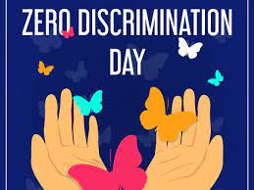**Title**: **Celebrating Diversity: Zero Discrimination Day**

**Introduction:**

Zero Discrimination Day, observed annually on March 1st, serves as a powerful reminder of the universal right to live free from discrimination. Rooted in the principles of equality and human dignity, this day shines a spotlight on the need to eliminate all forms of discrimination, fostering inclusive societies where every individual is respected and valued.

**Understanding Zero Discrimination Day:**

Zero Discrimination Day was established by the United Nations to promote diversity, tolerance, and acceptance worldwide. It serves as a platform to raise awareness about the detrimental effects of discrimination and the importance of upholding human rights for all.

The day is not only a call to action but also a celebration of the rich tapestry of humanity. It recognizes that diversity is our strength and underscores the need to embrace differences, whether they be in race, ethnicity, gender, sexual orientation, religion, disability, or any other characteristic.

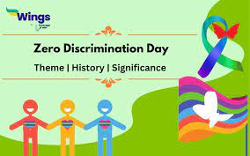

**Themes and Campaigns:**

Each year, Zero Discrimination Day is marked by a specific theme that addresses key issues related to discrimination. Past themes have focused on topics such as combating stigma and discrimination against people living with HIV/AIDS, promoting gender equality, and advocating for LGBTQ+ rights.

Campaigns organized around Zero Discrimination Day aim to challenge stereotypes, raise awareness, and foster dialogue on issues of discrimination. Through social media campaigns, community events, and advocacy efforts, individuals and organizations around the world come together to promote a message of inclusion and acceptance.

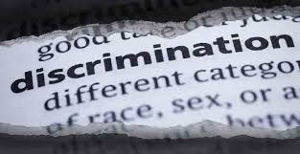

**Consequences of Discrimination:**

Discrimination has far-reaching consequences, not only for those directly affected but also for society as a whole. It perpetuates inequality, undermines social cohesion, and denies individuals the opportunity to fully participate in society. Discrimination can lead to social exclusion, economic disparities, and even violence, exacerbating existing inequalities and hindering progress towards sustainable development.

**Promoting Diversity and Inclusion:**

To combat discrimination, it is essential to promote diversity and inclusion in all aspects of life. This requires proactive measures to address systemic barriers, challenge discriminatory attitudes and practices, and create environments where everyone feels valued and respected.

Education plays a crucial role in promoting understanding and empathy, fostering a culture of acceptance and inclusion from an early age. By promoting diversity in workplaces, schools, and communities, we can create environments where everyone has the opportunity to thrive regardless of their background or identity.

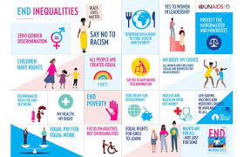

**Taking Action:**

Zero Discrimination Day is a call to action for individuals, communities, and governments to take concrete steps to combat discrimination. This may include advocating for policy changes, supporting marginalized communities, and speaking out against discrimination whenever and wherever it occurs.

**Conclusion:**

Zero Discrimination Day serves as a powerful reminder of our collective responsibility to build a world free from discrimination. By promoting diversity, fostering inclusion, and standing up against discrimination in all its forms, we can create a more just and equitable society where everyone has the opportunity to live with dignity and respect.

